Hello everyone,

Thank you for a productive meeting yesterday. We’ve clearly got a long road ahead, but I am very optimistic that we can start making some significant progress, especially now that Dr. Kan has offered to help guide us towards incorporating elements from his existing telemetry system. Also, I really appreciated your willingness to speak your minds yesterday; our efforts will yield fruit only if you’re willing to speak up when something doesn’t make sense, sounds like a poor fit for your skillset, or sounds too challenging, and speaking up is the only way we can make sure we all stay on track.

From next week on our meetings will involve **much** less time with me blathering on, and much more time spent in discussion about progress, current problems, and discussing next steps. So please be prepared each week to talk about what you’ve been able to accomplish, what you’re having trouble with, and what you think you should be doing next. Along those lines, if you feel that a PowerPoint slide would help you to communicate with the group (e.g. including code you’re having trouble with, results from a simulation that don’t make sense, etc.), send me a slide (or slides) before our Tuesday meeting so I can put it on the screen for you. Also, I will be setting up a Gantt chart for us so that we can keep track of progress on, and assignments for, the different distinct parts of the whole system (we’ll add assignments together on Tuesday). I will send links for the GitHub repository in the next day or so.

Also, for as many meetings as Dr. Skovira (and possibly Dr. Kan) can join us, please don’t hold back questions about technical details. I noticed yesterday that the four of you wanted to talk to Dr. Skovira after our meeting, but you should feel free to discuss all aspects of the project during our meetings in the future. I will be designing the mobile nodes of this system, and would definitely benefit from any advice you get from discussing details with Dr. Skovira or Dr. Kan. Please CC both me and Dr. Skovira on any email discussions about this project so we can both have the opportunity to weigh in and stay informed.

OK, so here’s my understanding of what’s on the table for next week:

**@Russell (and possibly Mei and Nathan):** I believe we decided at the meeting that the best course of action for this week is for Russell is to concentrate on the following:

1. Learning about the CC1310’s capabilities, specifically with respect to whether in-phase and quadrature information are made available to the user.
2. If I and Q are not available, then all three of you (Russell, Mei, Nathan) may need to identify an alternative working architecture for the RF front-end. In this week’s PowerPoint I added a slide with my first-pass idea of how that might look. Important design considerations are written in red. Incidentally, we have used the AD8348 demodulator in the past, and it appears to work well, but we’d need three of them.

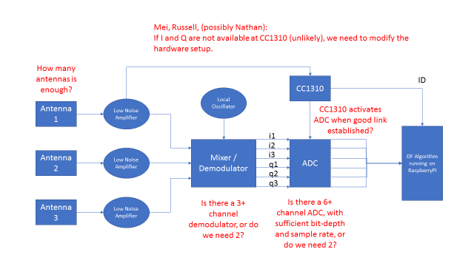

**@Mei:** It sounds to me like we still need to solidify exactly what part of the system you’ll be taking on, but for the time-being we definitely need help with 1) the RF front-end hardware, and 2) signal processing with a multiple-frequency approach. It sounds like the latter more closely aligns with your background. If you wanted to try to build a SIMULINK model to simulate how we would go about doing “ranging” (sensu Dr. Kan), that would be extremely useful. We need to get a sense for the effect on ranging accuracy of:

1. Using sub-GHz bands (e.g. ~166 +/- MHz)
2. Varying the number of frequencies used
3. Varying frequency spread between these bands
4. Various levels and sources of multi-path interference

I imagine you’d want to work closely with Dr. Kan, especially since he may already have SIMULINK models that might be adaptable.

In the future, we’ll need help with simulating and building the trilateration algorithm as well, and your help with this would be invaluable, but we should stick to the basic single-receiver (i.e. 2 or 3 antennas) ranging problem first.

**@Peidong:** I believe your original focus of determining how to interface the CC1310 to the Raspberry Pi is still an important goal, so I don’t think we need you to concentrate on anything else at the moment. Be aware though, that much of what we’re hoping to ask the CC1310 to do may have to be off-loaded to the demodulator and ADC (both of which may end up not being located on the CC1310 itself). So the most important part of the ground-node’s CC1310-related duties may eventually only be:

1. Triggering the ADC when a good link is established, and
2. Transferring the ID of the mobile node in contact to the Raspberry Pi (see diagram above)

Just something to keep in mind as you work on learning about the CC1310 – Pi interface.

**@Nathan:** You have been working on the mobile-node to ground-node communication protocol. Because we’re now thinking about employing some version of Dr. Kan’s multi-frequency trilateration approach, this will need to be reflected in the communication protocol. So, not only do the tags need to be able to transmit without stepping on each other’s toes, but they also have to transmit at a range of frequencies. How much of a frequency range we’re talking, and how many distinct frequencies is something that Mei may be working to simulate, so you may want to coordinate with her to get a ballpark idea of what we’ll need to ask the CC1310 to do. Depending on the range of frequencies it appears to me that there may be two primary options:

1. FSK modulation (where we use a single carrier frequency but modulate the signal on two [ideally more] frequencies). I doubt this is likely to be sufficient, since the frequency spread with FSK is likely to be very small, but it would be far simpler to implement since the mobile and ground nodes wouldn’t have the problem of having to stay synchronized across different distinct bands.
2. Frequency hopping, where the transmitter rapidly switches between widely spaced channels, and the receiver switches to receive on those same frequencies. I am unclear about how well supported this is on the CC1310, but this appears far more likely to get us the frequency spread we want, though it introduces the need for the ground nodes to stay synchronized with the mobile nodes. Given that the mobile nodes will likely only be synchronized once every 5 minutes to save mobile-node power, this could be a challenge (though not necessarily).

* * *

OK, that’s all for now. Please let me know (as always) if any of this is unclear, or you believe you should be doing something other than what I’ve outlined here. Enjoy the rest of your week, and I look forward to hearing about progress on Tuesday!

Cheers,

Julian